**Experiment No : 4**

**AIM**

Familiarization of LINUX Commands.

**CO2**

Perform system administration task.

**Procedure**

1. cut

a command for cutting out the sections from each line of files and writing the result to standard output

* 1. cut –b1 [filename]

to cut and display contents of file by 1st byte position.

$ cut –b1 file.txt

Output

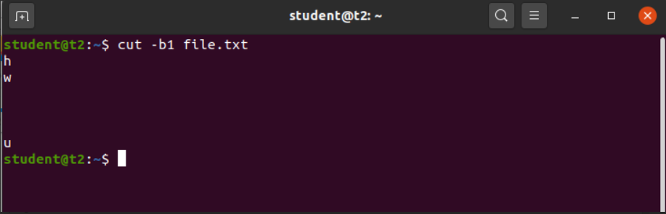

* 1. cut -c1 [filename]

to cut and display contents of file by 1st character position.

$ cut –c1 file.txt

Output

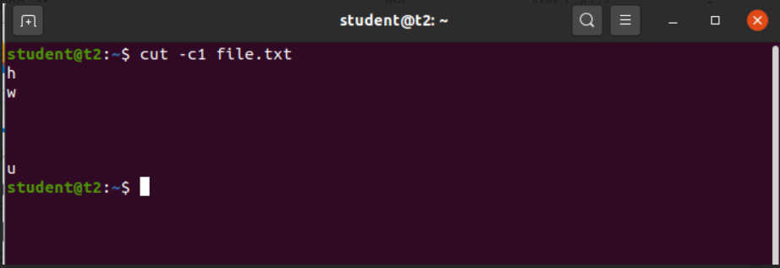

* 1. cut -d [delimiter] -f1 [filename]

to cut and display the column specified separated using the delimiter.

$ cut -d - -f1 samplef

Output

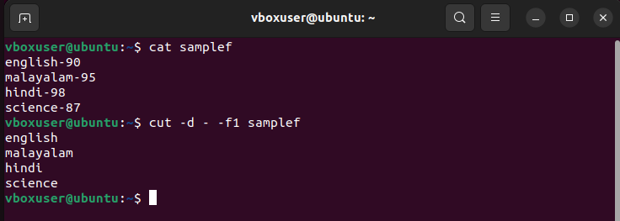

* 1. cut –c [character positions] [filename]

to cut and display contents of specified character position.

$ cut –c 1,4,6 file.txt

Output

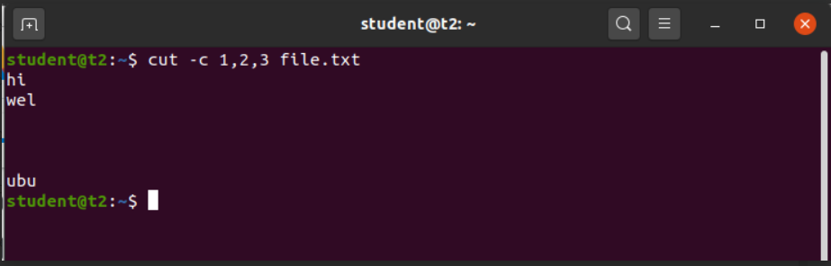

1. paste

command used to join files horizontally , each file consisting of different lines.

* 1. paste [sourcefile] [copyfile]

to copy and paste the contents of file 1 to file 2.

$ paste samplef file.txt

Output

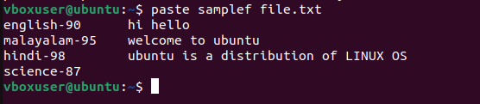

* 1. paste –d [delimiter] [sourcefile] [copyfile]

to copy and paste the contents of file 1 to file 2, separating them with specified delimiter.

$ paste –d ‘%’ samplef file.txt

Output

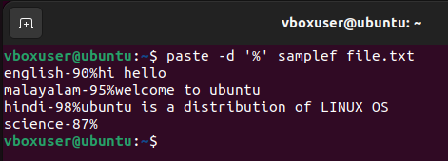

* 1. paste –d [delimiter] [filecontent1] [filecontent2] > [copyfile]

to copy and paste the contents of file 1,file 2 to file 3, with separating each file

content with specified delimiter.

$ paste –d ‘%’ samplef mark > mark1

Output

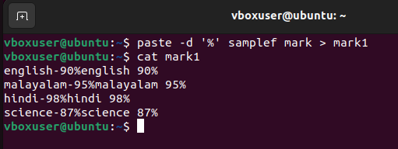

* 1. paste –s [filename]

to print the contents of file in single line.

$ paste –s

Output

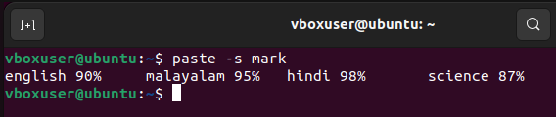

3) cp

to copy contents of a file to another file.

3.1) cp [sourcefile] [copyfile]

to copy contents of file1 to file2 by overwriting the contents of file2.

$ cp mark mark1

Output

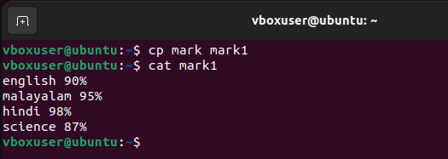

3.2) cp –r [source directory] [copy directory]

To copy the directory to another along with its subdirectory.

$ cp –r sample sample1

Output

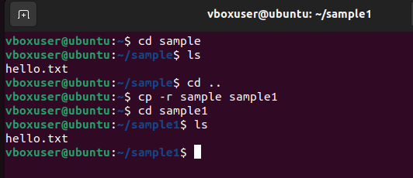

Result

The program has been executed and output has been verified.